TECHNICAL SPECIFICATION

Power Generation Project

Project name: Project
Date: Mar, 2009
Product type : Stationary power plant
Engine configuration: 3×SXD-MAN 8L32/40

Contents
Ⅰ General 3
Main data of the power plant 3
Derating of DG output 3
Water requirement 3
Quality of Light Fuel Oil (LFO) 3
Quality of Heavy Fuel Oil (HFO) 3
Lube oil characteristics 3
Codes and standards 3
Ⅱ. General layout 3
Main DG building 3
DG room 3
Auxiliary room 3
Switching room 3
Cooling water station 3
Tank area 3
Heavy fuel oil treatment station 3
Ⅲ. Diesel generating set 3
Specification of DG set 3
Main data of diesel engine 3
Main data of generator 3
Performance of DG set 3
Ⅳ Mechanical auxiliary system 3
Fuel oil system 3
Lube oil system 3
Cooling water system 3
Compressed air system 3
Air intake/Gas exhaust system 3
Ⅴ. Electrical control system 3
Electrical equipment 3
Primary cabling 3
Secondary circuit 3
DC system 3
Performance data detection 3
Main alarms of DG sets 3
Engine control 3
Auxiliaries control 3
Factory power supply 3
Ⅵ. Project and scope of supply 3
Boundary 3
Scope of supply 3

Ⅰ General
The proposed stationary 3 x 3.5MW diesel power generating plant is for base load application and intended for electricity production operation in parallel with public supply system.
The diesel engine is connected with the generator via flexible coupling. The fuel for DG sets can be either diesel oil or heavy fuel oil.
The mechanical auxiliary equipment of the DG will be grouped into functional modules to facilitate installation and operation.
Single bus design is used for its electrical design i.e. the power generated from 3 DG sets will be output to the bus. Power supply for the equipment in power plant itself will be taken from the bus through 11kV/0.4kV transformer. No additional standby generating sets are needed.

Main data of the power plant
The power plant mainly consists of 3 sets CHF3500/11000 diesel generating sets manufactured by Shaanxi Diesel Heavy Industry Co., Ltd. (SXD).
Rated power of each DG set under rated speed and ambient conditions:
- Electrical power (50/ 60Hz) 3500kW
- Apparent power 4375kVA
-Power factor 0.8
The DG set can output power efficiently under the following ambient conditions:
- Ambient temperature 5～45℃
- Elevation ≤1000M
- Relative humidity ＜95%
- Water temperature at air cooler inlet 45℃
The DG sets can output rated power continuously and are capable of temporary 110% overload for 1 hour in every 12 operating hours under the following conditions:
Ambient temperature 25℃
Atmospheric pressure 100kPa
Cooling water temp. at air cooler inlet 25℃

Derating of DG output
The output and fuel oil consumption rate are to be corrected according to relevant technical documents of the diesel engine manufacturer when the service condition on site does not conform to the standard conditions specified in ISO3046-1995.

Water requirement
HT water and injector cooling water
Normal condition | Clear
PH | 6.8--8
Total hardness (CaCO₃ in ppm) | mg/l | max | 100
Chlorinity | mg/kg | max | 60
Total salinity | mg/kg | max | 250
Density of acid ion ( SO²⁻₄) | mg/kg | max | 60
Fe | mg/kg | max | 0.3
Silicon dioxide | mg/kg | max | 50
Residue on evaporation | mg/kg | max | 400

Quality of Light Fuel Oil (LFO)
Viscosity, min. | cSt at 40℃ | 2.8
Viscosity, max. | cSt at 40℃ | 14.0
Density, max. (at 15 °C) | g/ml | 0.92
Conradson carbon res. max. | % mass | 3.0
Sulphur, max. | % mass | 2
Vanadium, max. | ppm | 100
Sodium, max. |  | 0
Ash, max. | % mass | 0.05
Water, max. | % Vol | 0.30
Water before engine, max. | % Vol | 0.2
Flash point, closed Pensky-Martens, min. | ℃ | 60
Pour point, upper max. | ℃ | 6
Aluminium + silicon, max. | mg/kg | 25
Total sediment potential, max. | % mass | 0.1

Quality of Heavy Fuel Oil (HFO)

Fuel oil specification
CIMAV 2003 |  |  |  |  | A30 |  | B30 | D80 | E/F180 | G/H/380 | H/k700
BS MA-100 |  |  |  |  |  |  | M4 | M5 | M7 | 8/9 | M9/-
ISO F-RM |  |  |  |  | A30 |  | B30 | E/F180 | E/F180 | G/H/K380 | H/K700
Fuel-system related characterstic values
Viscosity(at 50℃) | mm²/s(cSt) |  |  | max. |  | 40 | 40 | 80 | 180 | 380 | 700
Viscosity(at 100℃) |  |  |  | max. |  | 10 | 10 | 15 | 25 | 35 | 55
Density(at 15℃) | g/ml |  |  | max. |  | 0.975 | 0.981 | 0.985 | 0.991/1.010
Flash point | ℃ |  |  | min. |  | 60
Pour point(summer) |  |  |  | max. |  | 6 | 24 | 30
Pour point(winter) |  |  |  | max. |  | 0 | 24 | 30
Engine-related characteristic values
Carbon residues(Conradon) | % wt. | max. |  |  | 10 |  | 10/14 | 14 | 15/20 | 18/22 | 22
Sulphur | % wt. |  |  |  | 3.5 |  | 3.5 | 4 | 5
Ash | % wt. |  |  |  | 0.10 |  |  |  | 0.15 |  | 0.20
Vanadium | mg/kg |  |  |  | 150 |  | 150/300 | 350 | 200/500 | 300/600 | 600
Water | % vol. |  |  |  | 0.5 |  |  | 0.8 | 1
Sediment(potential) | % wt. |  |  |  | 0.1
Supplementary characteristic values
Aluminium and silicon | mg/kg |  | max.
Asphalts | % wt.
Sodium | mg/kg
Cetance number of low-viscosity constituent minimum 35
Fuel free of admixtures not based on mineral oil, such as coal oils or vegetable oils; free of tar oil and lubricating oil(used oil)

Lube oil characteristics
Lube oil for engine lubrication and rockerarm lubrication:
Viscosity: SAE40
Total base number (TBN): ＞20
Please consult recommended lube oil specifications of the engine manufacturer for specific lube oil to be used.
Lube oil for governor and turbocharger:
HU45(GB2537-81)

Codes and standards
The plant will be designed and manufactured according the following codes and standards.
Mechanical system: Relevant ISO and GB standards
Electrical system: IEC standards.

Ⅱ. General layout
This 3 x3.5 MW diesel power generating plant will occupy an area dividing into four sections i.e. main DG building, cooling water station, tank area and heavy fuel treatment station.

Main DG building
The main DG building consists of three rooms i.e. switching room, DG room and auxiliary room.

DG room
The elevation of the DG room is approx. 16m equipped with a 7 ton bridge crane for maintenance and lifting of components. 6 DG sets are laid out in parallel transversally.

Auxiliary room
The auxiliary room is on the engine side of the DG room . Auxiliary equipment such as oil pumps, water pumps, heat exchangers, air compressors, air bottles and some pipes will be installed in the room and the air intake and gas exhaust pipes as well as HT water expansion tank will be installed at the top of the room.

Switching room
Switching room is located at the generator side of the DG room. There are specific rooms for high voltage, central control, switching gear and transformer.

Cooling water station
A fresh water pond will be build in the Plant. Low temperature water circulating pump, central plate heat exchanger and LT water circulating pump. Plant water treatment facilities are located in the water treatment room. There is a water pump room for distinguish pump and pumps for daily life and production.

Tank area
Fuel oil storage tanks in the tank area will be built together comprising two or three 1,000m³ fuel oil storage tanks and eight 40m³ light diesel oil service tank. The capacity of the fuel oil tanks can enable the operating of 3 DG sets for days.
Position for slag oil is reserved in the tank area. Transfer pumps for light diesel oil and heavy fuel oil will be installed inside the tank area.

Heavy fuel oil treatment station
Heavy fuel oil separating unit is located in the station. The unit consists of 1centrifugal separators and feed pump, strainer and heater. Its function is to separate water content and particles in the heavy fuel oil which are hazardous to engine.

Ⅲ. Diesel generating set
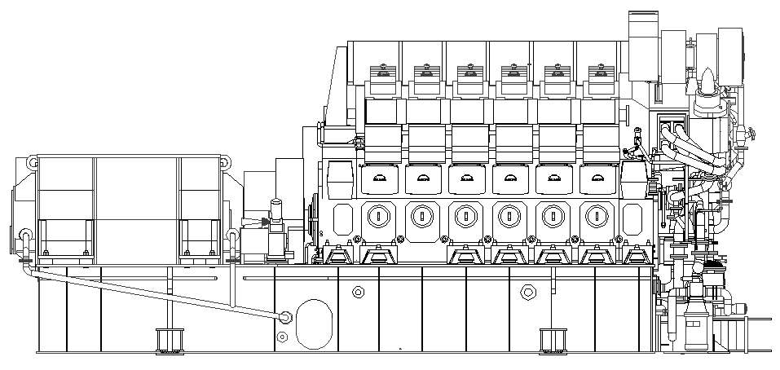
CHF3500/11000 DG set consists of one set of MAN 8L32 / 40 diesel engine as prime mover, one generator, excitation system and AVR, control and monitoring system, protection system and various auxiliary equipment. The diesel engine and the generator will be installed on the common base and connected through flexible coupling. The DG set features reliable running, prolonged TBO and easy maintenance.

Specification of DG set
Type CHF3500/11000
Rated power 35000 kW
Rated voltage 11kV
Rated current 230A
Number of pole pairs 4
Power factor 0.8 (lagging)
Rated frequency 50 Hz
Rated speed 750 r/min
Phase 3 phase
Excitation brushless excitation
Dry Weight 77ton
※External dimension(L×W×H) 10,875 x 2,710 x 5,120 mm
※ The dimensions and weight may vary depending on the generator make and type.

Main data of diesel engine
12V32/40 engine is a four stroke, single action, direct injection, gas turbocharging, intercooler medium speed high power diesel engine.
Type | 8L32/40
Model | 4 stroke, V-type, direct injection, gas turbocharging, air intercooled
N0. of cylinders | 8
Rotating direction | clockwise (view from PTO)
Cylinder bore | 320 mm
Stroke | 400 mm
Swept volume | 32.17 dm³
Compression ratio | 14.5/1
Type of combustion chamber | direct injection
Injection method | mechanical drive, single body injection pump
Starting method | compressed air starting
Max. continuous rating (MCR) | 4000kW
Overload power (1h out of 12 h) | 4400kW
Rated speed | 750 r/min
Mean effective pressure | 2.49MPa
Max. explosion pressure | 19.0±0.29MPa
Min. stable speed | 250 r/min
Firing speed | 80 r/min
Exhaust temp. at cyl. outlet | 510±50℃ (difference between any two cylinders ≤50℃)
Fuel oil consumption | 185+5％ g/kw.h （Lev= 42700kj/kg）
Lube oil consumption | ≤1.0 g/kw.h
External dimension | 7,270 x 2,635 x 4,170 mm（L×W×H）
Weight (dry) | 47 ton

Main data of generator
Type TFW3500-8/1730
Rated power 3500kW
Rated voltage 11kV
Rated speed 750 r/min
Rated frequency 50Hz
Power factor 0.8 (lagging)
Efficiency 96%
Insulation Class F
Protection IP23
Cooling method Air cooling
Excitation Brushless excitation
Lubricating method Complex lubricating
Bearing lube oil N46 (GB443-89)
Weight
External dimension

Performance of DG set
Steady state voltage deviation ±2.5%
Transient voltage regulation within +20%～ -15%
Voltage recovery time ≤1.5 second
Voltage fluctuation ≤1%
No-load voltage setting range 95% --105% rated voltage
The distortion rate of sinusoidal waveform
of line voltage at no-load rated voltage. ≤5%
Steady state frequency deviation 5%
Transient frequency deviation ±10%
Frequency recovery time 7 second
Frequency fluctuation ≤1%

Ⅳ Mechanical auxiliary system
The proper function of the DG-set is dependent on the mechanical auxiliary systems. The proposed systems have been optimized for the this particular plant. The function of the systems are to provide the engine with fuel, lubricating oil, starting air, cooling water and charge air at required quantity and quality as well as to dispose of exhaust gases in a proper manner.

Fuel oil system
The main function of the fuel oil system is to supply the Diesel engine with fuel oil of the necessary amount, pressure, temperature, viscosity and quality during all loads and environmental conditions.. The power plant is using Heavy Fuel Oil as the main fuel.
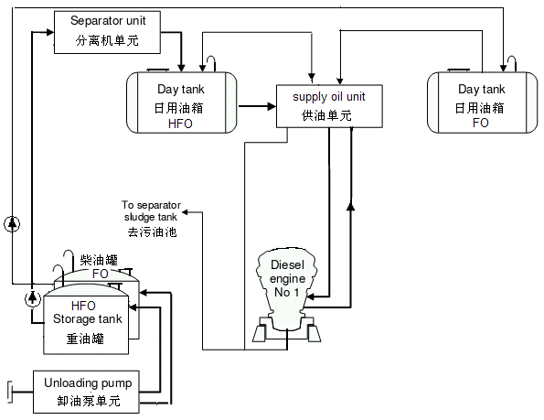

1. Fuel oil storage system
Diesel oil transfer pumps are to be equipped to facilitate unloading of fuel oils. The diesel oil transfer pump is for delivering diesel oil to the diesel oil daily tank for starting ,running and stop operations of the DG sets.
Main facilities in the fuel oil storage system are
Strainer 8 sets
LFO transfer pump 4 sets
LFO delivery pump 2 sets
LFO daily tank 8 set
LFO storage tank 2 sets
Light fuel oil daily tanks are all equipped with level indicator and level switches for alarm and control.

2. FO feeding unit 3 sets
The function of the feeding pump unit is to pump fuel oil from the storage tank to the day tank. It provides the engine with filtered fuel of correct quantity and pressure. It consists of feeding pump, fine filter, flow meter, booster pump, and control system. Its function is to supply fuel oil to diesel engine at an appropriate viscosity, pressure, flow and cleanness. Transfer pumps and other components are built on a steel frame, which forms one compact unit. Every two DG sets share one unit
Main facilities are as follows:
Electric feeding pump 2 sets
Electric booster pump 2 sets
Duplex strainer 2 sets
Duplex fine filter 1 set
Pressure drop indication and alarm 1 set
Control panel 1 set
Connecting pipe, valve, flanges 1 set
Steel base frame 1 set

3. Heavy fuel oil separating unit 1 sets
The unit consists of 2 centrifugal separators and feed pump, strainer and heater. Its function is to separate water content and particles in the heavy fuel oil which are hazardous to engine.
Its working procedure is as follows:
First heat up the HFO coming from HFO storage tank to a temperature suitable for separation.
Then separate the HFO according to its nature through appropriate gravity disk.
HFO after the treatment will be delivered to HFO daily tank. The slag and contaminated water will be drained to slag collector. Switch on the slag oil pump to drain it to slag oil tank when the slag in the collector accumulates to certain amount.

4. HFO feeding unit
It consists of feeding pump, fine filter, flow meter, blending device, booster pump, heater and viscosity-temperature control system. Its function is to supply fuel oil to diesel engine at an appropriate viscosity, pressure, flow and cleanness and realize the switch over between diesel oil and HFO. Every two DG sets share one unit.
Its working procedure is as follows:
Measure the temperature and viscosity of the HFO coming from HFO daily tank through thermal transmitter and viscometer. Heat up the HFO automatically to the set temperature, at which the viscosity of HFO can ensure the normal operation of the diesel engine. Finally feed the HFO after fine filtration to DG sets though the booster pump.
Main facilities are as follows:
Electric feeding pump 2 sets
Electric booster pump 2 sets
Degas blending tank 1 set
Duplex strainer 2 sets
Fuel oil heater 1 set
Temperature-viscosity control device 1 set
Duplex fine filter 1 set
Pressure drop indication and alarm 1 set
Control panel 1 set
Connecting pipe, valve, flanges 1 set
Steel base frame 1 set

Lube oil system
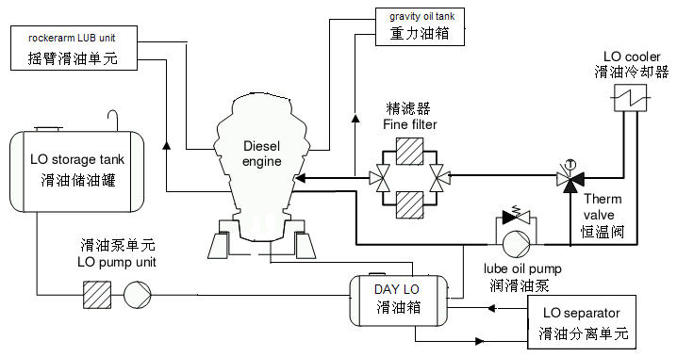
DG lubricating system consists of diesel engine lubricating system and generator lubricating system. The diesel engine lubricating system includes main lube oil circuit, rockerarm lubricating circuit and turbocharger self lubricating system.

1. Main lube oil circuit of diesel engine 1 set/DG set
The main lube oil system of the diesel engine is to supply lube oil for moving parts of the engine. Main lube oil pump delivers lube oil from lube oil tank to engine inlet through lube oil fine filter. Lube oil cooler and three-way thermostatic valve ensure the temperature of the lube oil at engine inlet.
Main facilities are as listed below:
Electric lube oil delivery pump 2 sets
Lube oil cooler 1 set
Lube oil fine filter 1 set
Thermostatic valve 1 set
Control panel 1 set
Connecting pipes, valves, flanges 1 set
Steel base frame 1 set

2. Lube oil separating unit 3 sets
The function of lube oil separating unit is to separate the water content and particles in the main lubricating system at fixed intervals. Two DG sets share one unit. Lube oil of two DG sets can be separated during operation of DG sets.
Each lube oil separating unit consists of the following facilities:
Lube oil separator 2 sets
Filter 2 sets
Heater 2 sets
Slag oil tank 1 set
Control panel 1 set
Connecting pipe, valve, flange 1 set
Steel base frame 1 set

3. Lube oil storage system 1 set/Plant
For storage, compensation and refill of lube oil for the Plant.
Lube oil storage tank 1 set
Lube oil delivery pump 1 set
Engine circulating lube oil tank 1 set
Waste oil tank 1 set

4. Emergency lube oil system
For supplying necessary lube oil for stop of engine when accidents such as loss of power, faulty lube oil pump etc.
Main facilities:
Gravity oil tank 8 sets
Automatic oil feeding device 8 sets

Cooling water system
Engine cooling water system comprises three portions i.e. high temperature water circuit, low temperature water circuit and injector cooling circuit. LT water is cooled by cooling tower. HT water and injector cooling water are cooled by LT water through heat exchangers.
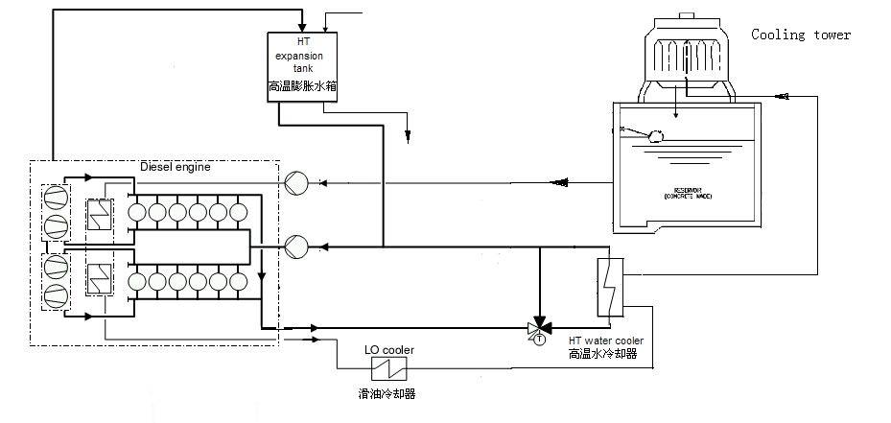
1. LT water circulating system 1 set/Plant
LT water circulating system consists of pump station and cooling tower. Its function is to cool air cooler, lube oil cooler, HT water cooler and injector cooler.
Main facilities are as follows:
LT circulating pump 6 sets
Cooling tower 6 sets

2. HT water system 1 set/DG
HT water system is to cool cylinder liners, cylinder heads and turbocharger consisting of cooling unit and expansion tank.
Main facilities included in the cooling unit are:
HT water pump 2 sets
HT water cooler 1 set
Thermostatic valve 1 set
Control panel 1 set
Connecting pipe, valve, flange 1 set
Steel base frame 1 set

3. Injector cooling water system 1 set/DG
Main facilities are:
Injector cooling water pump 2 set
Injector cooler 1 set
Thermostatic valve 1 set
Cooling water tank 1 set
Control panel 1 set
Connecting pipe, valve, flange 1 set
Steel base frame 1 set

Compressed air system 1 set/Plant
The compressed air system is to supply compressed air for engine starting. Air cooled air compressor produces compressed air and the air will be stored in the starting air bottle and low pressure control air bottle. The capacity of the starting air bottle shall enable 12 times starting of the 2 DG sets.
Main facilities included are:
Air compressing unit 2 set automatic start/stop
Starting air bottle 4 sets
Control air bottle 4 set
Relief valve 4 set
Control air treatment device 4 set
Local air control panel 1 sets

Air intake/Gas exhaust system 1 set/DG
Air intake/gas exhaust system consists of air filter, air intake pipe, turbocharger, air cooler, air manifold, exhaust gas manifold, gas boiler and silencer.
The air outside the building enters into the turbocharger through air duct after filtration of the air filter. The high temperature air after supercharging is cooled by the air cooler and enters into cylinders for combustion through air pipes. The high temperature gas with high pressure after combustion enters into turbocharger through exhaust gas pipes and pushes the turbocharger to rotate and in the meantime drives air compressor for supercharging. The exhaust gas is divided into two routes, one is emitted into open air through silencer, the other goes to the gas boiler to produce steam. The flow of exhaust gas in each route can be regulated through valve.
Exhaust silencer 1 set
Air filter 1sets
Exhaust pipe expansion joint 1sets
Exhaust manifold expansion joint 1 sets
Air intake pipe expansion joint 1sets

Ⅴ. Electrical control system
The outgoing of 2 DG sets connected to the 11KV bus, which is single bus. The frequency of the local power grid is50/ 60Hz. The short circuit current of single DG set is 2.69kA. The max short circuit current of 11kV bus is 16.4kA. The 11kV circuit-breaker is indoor vacuum circuit-breaker, whose rated current is 20kA. The 11kV switchgear is indoor fixed switch cubicle.
The factory power is taken from 11kV bus via factory transformer to lower the voltage down to 0.4KV and connected to switchgear which supplies power to auxiliaries control system and for workshop lighting , ventilation, security and common equipment.
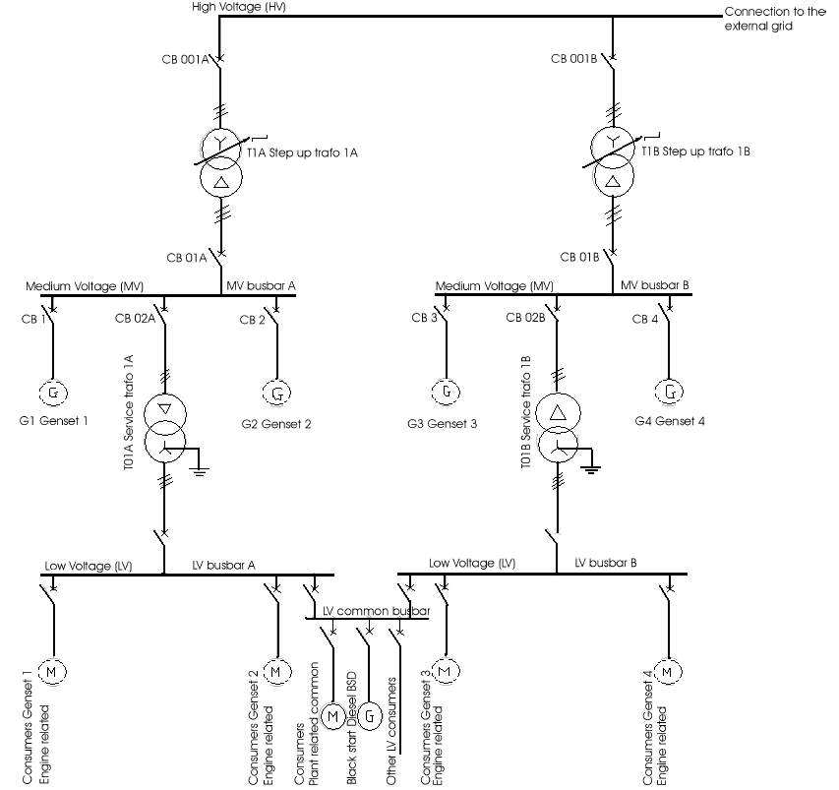
The 2 DG sets have an integrated control system, which performs the control, protection, monitoring functions of the DG sets.

Electrical equipment
No. | Designation | Quantity
1 | Local control panel | 3
2 | Generator control cubicle | 3
3 | PT cubicle | 3
4 | CT cubicle | 3
5 | Generator outgoing switch cubicle | 3
6 | Neutral earthing cubicle | 3
7 | Generator protection cubicle | 3
8 | DC24V panel | 2
9 | DC110V panel | 2
10 | Common pump control panel | 1
12 | 0.4KV control cubicle | 1
13 | 0.4KV switch cubicle | 1
14 | Factory power control cubicles | 1
15 | 0.4KV compensation panel | 1
16 | Transformer 11KV/0.4KV 1250KVA | 1
17 | 0.4KV outgoing cubicles | 1
18 | Transformer incoming switchgear cubicle | 1
19 | Busbar PT cubicle | 1
20 | 11KV outgoing cubicle | 1

Primary cabling
The primary cabling of the Plant is 11KV single bus. The output of 2 DG sets are all connected to 11KV bus. The final outgoing circuit and outgoing way shall be decided after confirmation with the customer. In this proposal the power output circuit is designed as two circuits output and the outgoing way as geosyncline cables.
In the 11kV bus of primary cabling diagram, the factory power supply is taken from the 11kV bus via 11kV/0.4kV factory transformer. The 11KV electrical cubicles for primary cabling are XN₂ fixed switch cubicle. The main equipment includes generator output cubicles, PT cubicles, neutral earthing cubicles, CT cubicles, outgoing switch cubicle and factory power transformer switch cubicle.
1 . Generator output cubicles
Automatic and manual breaker close and trip switch
Differential protection current signal
Generator neutral earthing fault protection
Circuit-breaker and motor heater interlock with fan motor.
Stop the generator heater when close the generator outgoing circuit-breaker and start the generator ventilation motor simultaneously. Stop the motor when the circuit-breaker trip.
Enable the manual and electrical operation of close and trip.
2. Neutral earthing cubicles
Supply the differential protection circuit current signal
Supply voltage signal for exciting automatic regulator
Supply current signal for zero sequence protection circuit
3. PT cubicle
Supply voltage signal for active power, reactive power, three-phase current, power factor and frequency measure.
Supply generator protection voltage signal
4. CT cubicle
Supply current signal for excition regulation and active and reactive power meter
Supply generator protection voltage signal
5. Outgoing cubicle
Supply outgoing circuit for power users.
6. Factory transformer switch cubicle
Supply power to factory transformer
7. PT cubicle
Supply bus voltage
Equipped with bus PT

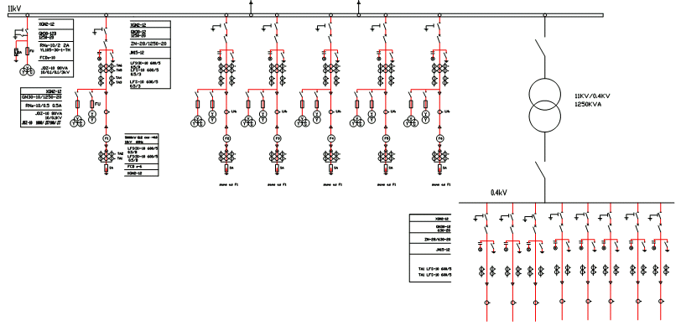
Secondary circuit
The secondary system of the Plant includes mainly he control, protection and monitoring system which uses normal magnetic relays. Generator protection and the protection of transformer and wirings are realized through integrated protection devices. The secondary protection devices are integrated into one control panel, which are installed in the control room.
DG sets and 11KV busbar use the manual synchronizer to realize the grid paralleling. The voltage and frequency regulation for grid paralleling is realized through central control table.
DG sets protection in secondary system contains the following :
- Differential protection
- Reverse power protection
- Overload protection
- Over voltage protection
- Combined under voltage and over current protection
- Neutral earthing protection
- Quick trip and over current protection for 11KV busbar outgoing switch
The electrical data of all DG sets are gathered at the central control table and displayed, recorded and printed by computer.

DC system
The DC power system of the Plant has two types of load current i.e. DC24V 20AH and DC110V 80AH.
The diesel engine and related instruments use DC24V. DC110V is used for main control room and other Plant control systems, protection and communication, and emergency lighting system.

Performance data detection
The performance data of all DG sets are communicated to the central control table and displayed, recorded and printed by computer.
- Air temp. at turbocharger inlet
- LT water temp. at air cooler inlet
- HT water temp. at engine outlet
- Lube oil temp. at engine inlet
- Lube oil pressure at engine inlet
- Pressure in LT water pipe
- HT water pressure at engine inlet
- Max explosion pressure
- Gas temp. at cylinder outlet
- Average exhaust gas temp., on one bank
- Exhaust gas temp. at turbine inlet
- Exhaust gas temp. at turbine outlet
- Vacuum at turbocharger inlet
- Exhaust backpressure at turbocharger outlet
- Turbocharger speed

Main alarms of DG sets
Temperature
- HT water temp. at engine outlet
- Lube oil temp. at engine inlet
- Lube oil temp. at turbocharger outlet
- Exhaust gas temp. at cylinder outlet
- Average exhaust gas temp. on each bank
Pressure
- Lube oil pressure at engine inlet
- Lube oil pressure at turbo charger inlet
- Fuel oil pressure at engine inlet
- Pressure in overspeed protection air receiver
Safety stop
- Overspeed protection
- Low lube oil pressure at engine inlet
- High HT water temp. at engine outlet

Engine control
There are two control mode for engine i.e. local control and central control, which can be selected by the local switch. The local control can facilitate maintenance and inspection works. Besides the instruments for easy monitoring, the local control panel also contains control elements for starting, stop, emergency stop and speed regulation, which enable the start, stop, overspeed protection, emergency stop and local/central switchover operations. Each DG set is equipped with one LCP. Part of performance data such as engine speed, start air pressure, engine lube oil pressure at engine inlet are monitored by the special instruments.

Auxiliaries control
Control of auxiliaries of engine includes:
Fuel oil pump
Lube oil pump
HT water pump
LT water circulating pump
Injector cooling water pump
Rockerarm lube oil pump
Turning gear motor
start air compressor
Generator ventilation motor (half pipe type )
Generator heater
The start and stop of most auxiliary pumps are controlled by the units in this system. Auxiliary unit shall have its own local control box. Some auxiliaries are controlled in distributing room.3 DG sets share one panel .

Factory power supply
The factory power supply is taken from 11kV bus via the 1250kVA transformer to lower the voltage from 11kV down to 0.4KV and connected to switchgear which supplies power to auxiliaries control system and for workshop lighting, ventilation, security and common equipment. There is automatic power factor compensation device on the 0.4KVbusbar to guarantee the efficiency of DG sets and power supply quality.

Ⅵ. Project and scope of supply
Design and building of all the buildings and facilities within the Plant. Laying of cooling tower cooling pipes for the Plant.

Boundary
The interface between the 11kV bus and the city grid is the outer side of the outgoing bus switch.
The water supply will come from the city water supply system. The interface is at 1 meter outside of the territory of the Plant.
The drain water of the Plant will go to the infiltration basin outside of the Plant.
The interface between the communication system and the city communication network is at 1 meter outside of the territory of the Plant

Scope of supply

Item No. | Description | Required |  | Scope
Item No. | Description | Qty | Unit | SXD | CT
A | DIESEL GENERATING SET
A.1 | Diesel Engine 8L32/40 4000kw, 750 r/min | 3 | Units | ■
A.1.1 | Turbocharger | 3 | pcs | ■
A.1.2 | Air Cooler | 3 | pcs | ■
A.1.3 | Governor | 3 | pcs | ■
A.1.4 | Fuel Injection Pumps | 24 | pcs | ■
A.1.5 | Instrumentation | 3 | pcs | ■
A.1.6 | Protection devices | 3 | sets | ■
A.1.7 | Junction box | 3 | sets | ■
A.1.8 | Engine Common base | 3 | sets | ■
A.1.9 | Flywheel | 3 | sets | ■
A.1.10 | Flywheel turning device | 6 | sets | ■
A.1.11 | Leak Oil Tank | 3 | sets | ■
A.1.12 | Wedges and anchor bolts | 3 | sets | ■
A.1.13 | Maintenance platforms | 3 | sets |  | ■
A.1.14 | Alternator with AVR, 6375kva,50Hz,11kv | 3 | sets | ■
A.1.15 | Engine Special Tools | 1 | set | ■
A.1.16 | Commissioning Spare Parts | 1 | set | ■
B | LIGHT FUEL OIL (LFO) SYSTEM
B.1 | LFO Storage Tank | 1 | Units |  | ■
B.2 | Level Indicator for LFO Storage tank | 1 | Set | ■
B.3 | LFO Unloading Pumps | 2 | Units | ■
B.4 | Strainers for LFO Unloading Pumps | 2 | Pcs | ■
B.5 | LFO Day Tank | 1 | Unit |  | ■
B.6 | Level Switch LFO Day tank | 2 | Sets | ■
B.7 | Level Switch LFO Day tank | 1 | Set | ■
B.8 | Level Gauge LFO Day tank | 1 | Set | ■
B.9 | LFO Transfer Pumps | 2 | Units | ■
B.10 | Strainers for LFO Transfer Pumps | 2 | Pcs | ■
B.11 | LFO Flow meter | 1 | Pc | ■
B.12 | Strainers for LFO Flow meter | 1 | Pc | ■
B.13 | LFO Filter Unit | 2 | Sets | ■
B.14 | Piping | 1 | Lot |  | ■
B.15 | Valves | 1 | Lot | ■
B.16 | Gauges 1 |  | Lot | ■
C | HEAVY FUEL OIL (HFO) SYSTEM
C.1 | HFO Storage Tank | 2 | Unit |  | ■
C.2 | Level Indicator for HFO Storage Tank | 1 | Set | ■
C.3 | HFO Unloading Pumps | 4 | Units | ■
C.4 | Strainers for HFO Unloading Pumps | 4 | Pcs | ■
C.5 | HFO Storage Tank Transfer Pumps | 2 | Units | ■
C.6 | Strainers for HFO Transfer Pumps | 2 | Pcs | ■
C.7 | HFO Settling Tank | 1 | Unit |  | ■
C.8 | Level Switch for HFO Settling Tank | 2 | Sets | ■
C.9 | Level Switch for HFO Settling Tank | 1 | Set | ■
C.10 | Level Indicator for HFO Settling Tank | 1 | Set | ■
C.11 | HFO Service Tank | 1 | Unit |  | ■
C.12 | Level Switch for HFO Service Tank | 2 | Sets | ■
C.13 | Level Switch for HFO Service Tank | 1 | Set | ■
C.14 | Level Indicator for HFO Service Tank | 1 | Set | ■
C.15 | HFO (Centrifuge) Separator unit | 3 | Sets | ■
C.16 | HFO Conditioning Unit | 4 | Sets | ■
C.17 | HFO Drain Tank | 1 | Unit |  | ■
C.18 | Transfer Pumps for HFO Drain Tank | 2 | Units | ■
C.19 | Level Switch for HFO Drain Tank | 1 | Set | ■
C.20 | HFO/LO Sludge Tank | 1 | Unit |  | ■
C.21 | Transfer Pumps for HFO/LO Sludge Tank | 2 | Units | ■
C.22 | Level Switch for HFO/LO Sludge Tank | 1 | Set | ■
C.23 | Sludge Storage Tank | 1 | Unit |  | ■
C.24 | Transfer Pumps for Sludge Storage Tank | 1 | Unit | ■
C.25 | Sludge Recovery Pond (Concrete made) | 1 | Unit |  | ■
C.26 | Transfer Pumps for Sludge Recovery Pond | 1 | Unit | ■
C.27 | Transfer Pumps for Sludge Pit | 2 | Units | ■
C.28 | Level Switch for HFO/LO Sludge Tank | 1 | Set | ■
C.29 | Piping | 1 | Lot |  | ■
C.30 | Valves | 1 | Lot |  | ■
C.31 | Gauges and Thermometers | 1 | Lot | ■
D | LUBRICATING OIL SYSTEM
D.1 | Lube Oil Storage Tank | 1 | Unit |  | ■
D.2 | Lube Oil Unloading Pumps | 1 | Unit | ■
D.3 | Lube Oil Transfer Pumps | 2 | Units | ■
D.4 | Lube Oil Sump Tank | 3 | Units | ■
D.5 | Level Switch for LO Sump Tank | 3 | Sets | ■
D.6 | Lube Oil (Centrifuge) Separator unit | 3 | Sets | ■
D.7 | Lube Oil Cooler | 3 | Units | ■
D.8 | Prelubricating oil Pumps | 3 | Units | ■
D.9 | Lube Oil Circulation Pumps | 6
D.10 | Lube Oil Filter | 6 | Units | ■
D.11 | Lube Oil Filter for LO Transfer Pump | 2 | Pcs | ■
D.12 | Thermostatic 3-way valve | 3 | Pcs | ■
D.13 | Lube Oil Regulating Valve | 3 | Pcs | ■
D.14 | Piping | 1 | Lot |  | ■
D.15 | Valves | 1 | Lot | ■
D.16 | Gauges and Thermometers | 1 | Lot | ■
E | COMPRESSED AIR SYSTEM
E.1 | Starting Air Compressor | 2 | Units | ■
E.2 | Starting Air Receiver | 3 | Units | ■
E.3 | Air Reducing Valve Unit | 1 | Unit | ■
E.4 | Control Air header | 1 | Pc |  | ■
E.5 | Control Box | 1 | Units | ■
E.6 | Piping | 1 | Lot |  | ■
E.7 | Valves | 1 | Lot | ■
E.8 | Gauges | 1 | Lot | ■
F | RAW WATER COOLING SYSTEM
F.1 | Cooling Tower/ radiator cooling tower | 1 | Units | ■
F.2 | Raw Water Circulation Pumps | 6 | Units | ■
F.3 | Raw Water Storage Tank | 1 | Unit |  | ■
F.4 | Level Switch for RW Storage Tank | 1 | Set | ■
F.5 | Water Treatment System module | 1 | Set | ■
F.6 | Treated Water Storage Tank | 1 | Unit |  | ■
F.7 | Level Switch for Treated Water Storage Tank | 1 | Set | ■
F.8 | Treated Water Transfer Pumps(to Engine auxiliaries) | 2 | Units | ■
F.9 | Piping | 1 | Lot |  | ■
F.10 | Valves | 1 | Lot | ■
F.11 | Gauges and Thermometers | 1 | Lot | ■
G | JACKET WATER COOLING SYSTEM
G.1 | Jacket Water Circulation Pumps | 6 | Units | ■
G.2 | Jacket Water Cooler | 3 | Units | ■
G.3 | JW Thermostatic 3-way valve | 3 | pcs | ■
G.4 | JW Expansion Tank | 3 | Units |  | ■
G.5 | Level Switch for Expansion Tank | 6 | Sets | ■
G.6 | Nozzle Oil cooling pump | 6 | Sets | ■
G.7 | Piping | 1 | Lot |  | ■
G.8 | Valves | 1 | Lot |  | ■
G.9 | Gauges and Thermometers | 1 | Lot | ■
H | EXHAUST GAS SYSTEM
H.1 | Exhaust Gas Silencer | 3 | Units | ■
H.2 | Expansion Bellows (at Turbocharger) | 6 | pcs | ■
H.3 | Expansion Bellows (at Silencer) | 3 | pcs | ■
H.4 | Chimney of Smokestack | 1 | Lot |  | ■
H.5 | Piping/Ducting | 1 | Lot |  | ■
I | INTAKE AIR SYSTEM
I.1 | Air intake filter | 3 | Units | ■
I.2 | Input Air expansion joint | 6 | Units | ■
I.3 | Piping/Ducting | 1 | Lot |  | ■
J | DIESEL ENGINE CONTROL PANEL | 3 | Units | ■
K | GENERATOR & ELECTRICAL
K.1 | Generator Control Pane | 3 | Units | ■
K.2 | Station Transformer Control Pane | 1 | Unit | ■
K.3 | Outgoing Feeder Control Pane | 1 | Unit | ■
K.4 | Generator CB Pane | 3 | Units | ■
K.5 | Bus PT Panel | 1 | Unit | ■
K.6 | Station Transformer CB Panel | 1 | Unit | ■
K.7 | Outgoing feeder CB pane | 1 | Unit | ■
K.8 | LV General Input CB Panel | 1 | Unit | ■
K.9 | LV CB Panel | 3 | Units | ■
K.11 | Auxiliary Equipment Control Pane | 3 | Units | ■
K.12 | 110/24V DC System | 1 | Unit | ■
K.13 | All Transformers | 1 | Unit |  | ■
K.14 | Power and Control Cable | 1 | Lot |  | ■
L | GENERAL EQUIPMENT
L.1 | Maintenance Overhead Crane | 1 | Unit |  | ■
SXD: To be supplied by SXD CT: To be supplied by Customer

